Router DHCP Configuration with Packet Tracer

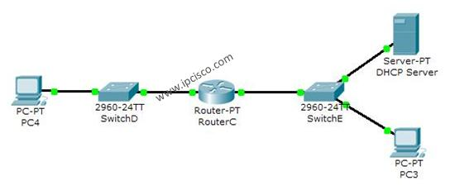

In this [**DHCP**](https://ipcisco.com/dynamic-host-configuration-protocol/) [**Cisco Packet Tracer**](https://ipcisco.com/cisco-packet-tracer-configuration-examples/) example, we will focus on **DHCP Configuration in Cisco Packet Tracer**. In other words, we will see how to configure a **DHCP Server with Packet Tracer**.

Before start-up I want to give some basic information about DHCP. As you know DHCP use UDP 67 and 68 ports. It has a messaging system for the communication between **DHCP Server** and **DHCP Client**. These messaging system’s messages and their types are mentined below:

**• DHCP Discover (broadcast)  
• DHCP Offer(broadcast)  
• DHCP Request (broadcast)  
• DHCP Ack (broadcast)  
• DHCP Nak (unicast)  
• DHCP Release (unicast)  
• DHCP Decline (unicast)  
• DHCP Inform (unicast)**

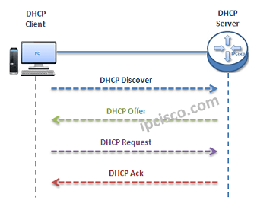

*DHCP Messages*

• You can also check [**DHCP Overview Lesson**](https://ipcisco.com/dynamic-host-configuration-protocol/) and [**DHCP IP Allocation Lesson**](https://ipcisco.com/dhcp-ip-allocation-operation/) to learn more.

• You can Reach [**All Cisco Packet Tracer Labs**](https://ipcisco.com/cisco-packet-tracer-configuration-examples/) and **DOWNLOAD** the **Packet Tracer Examples** with **.pkt** format.

• You can **DOWNLOAD** this lessons **Packet Tracer Example** with **.pkt** format [**HERE.**](https://ipcisco.com/wp-content/uploads/BGP/BGP_conf.pkt)

Firstly, a client sends a broadcast **“DHCP Discovery”** message that mentions that it need an ip address.  
  
Then, the **DHCP servers** reply with configuration offers to the client by **“DHCP Offer”**unicast message.  
  
After that **DHCP client** sends a broadcast **“DHCP Request”**message to the network with the **“Transaction ID”** of the first **DHCP Server** that send **Offer**. The other **servers** understand that **client**wants to use the **server**that has the related **“Transaction ID”**.  
  
Lastly, the **Server** sends a unicast**“Acknowledgement”** message to the **client** that mentions the ip assignment is successfully done or it send a refuse messaged named “**DHCP-NACK**”.

To configure a router’s DHCP, we must follow some basic steps. For this configuration the important point is broadcast domains. If we have only one broadcast domain in our topology, our work is simpler, else we must get help from **“ip-helper address”** command.  
  
What is **ip helper address** command? **Ip helper address command** is the command that helps us to convince the router and make it pass the broadcast packets.  
  
Now, let’s go to our two different configuration topology and see how to configure a **server**in packet tracer for DHCP, **how to configure a DHCP Server in packet tracer**.  
  
**For One Broadcast Domain**  
  
Our one broadcast domain topology is like below. There is a router that will carry our DHCP server role beside its routing functionalities. And there is a switch for PCs.

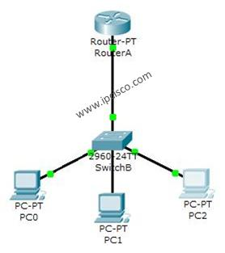

*DHCP Example Topology (One Broadcast Domain)*

Firstly, let’s see **How to Configure a DHCP Server** in Packet Tracer for **One Broadcast Domain**. For this first case of our **DHCP Cisco packet tracer example**, the **One Broadcast Domain** topology that we will use, is like below. There is a router that will carry out **Server** role beside its routing functionalities. And there is a switch for PCs.

On routerA, firstly we will give an ip address to the router interface that is connected to the switch.Secondly that we will create a DHCP pool named IPD. In this pool we will mention ip addresses that will be given to the DHCP clients.After that we will assign the router’s interface address as a default-router address for clients. And in the last part, we will exclude some addresses with “**ip dhcp excluded address**” command, that we don’t want to use during this dynamic ip assignments. With “**ip dhcp excluded address**” command, the mentined addresses will not used in the pool.

RouterA# **config terminal**

RouterA(config)# **interface fastEthernet 1/0**

RouterA(config-if)# **ip address 192.168.10.1 255.255.255.0**

RouterA(config-if)# **no shut**

%LINK-5-CHANGED: Interface FastEthernet1/0, changed state to up

%LINEPROTO-5-UPDOWN: Line protocol on Interface FastEthernet1/0, changed state to up

RouterA(config-if)# **exit**

RouterA(config)# **ip dhcp pool IPD**

RouterA(dhcp-config)# **network 192.168.10.0 255.255.255.0**

RouterA(dhcp-config)# **default-router 192.168.10.1**

RouterA(dhcp-config)# **exit**

RouterA(config)# **ip dhcp excluded-address 192.168.10.1 192.168.10.10**

RouterA(config)# **ip dhcp excluded-address 192.168.10.12 192.168.10.14**

|  |
| --- |
|  |

After this configuration, when we check the ip address of PC0, we will see the ip address 192.168.10.11 . Because it is the first available address in **DHCP pool**.

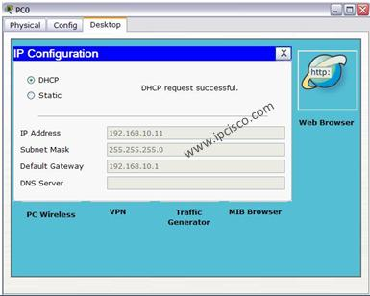

We can also check the pool information with Cisco “**show ip dhcp pool**” command.